Final Project Report
Title: Digital Cleanliness Monitoring System

Outcome
Developed a web-based cleanliness and grievance management platform where students can register complaints, upload images, track complaint status, submit feedback, and view campus events. Administrators can monitor complaints and update progress efficiently.

Tools Used with Version
Node.js (Runtime Environment), Express.js 4.21.2, MongoDB (Database), Mongoose 8.8.4, bcrypt 5.1.0 / bcryptjs 2.4.3, Multer 1.4.5-lts.1, Body-Parser 1.20.3, CORS 2.8.5, JavaScript, HTML, CSS.

Module Outputs
1. User Registration and Login
2. Admin Login
3. Complaint Registration with Image Upload
4. Complaint Status Tracking (Yet to Begin, In Progress, Resolved)
5. Event Management
6. Feedback Management
7. MongoDB Data Storage and Retrieval

Output Screenshot Explanations
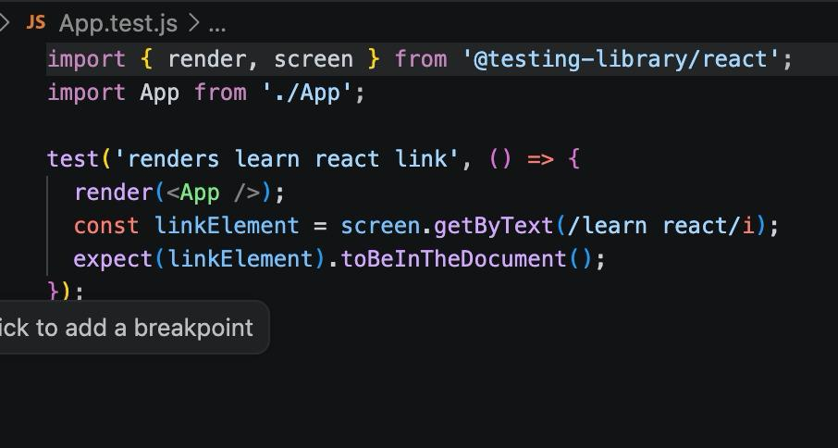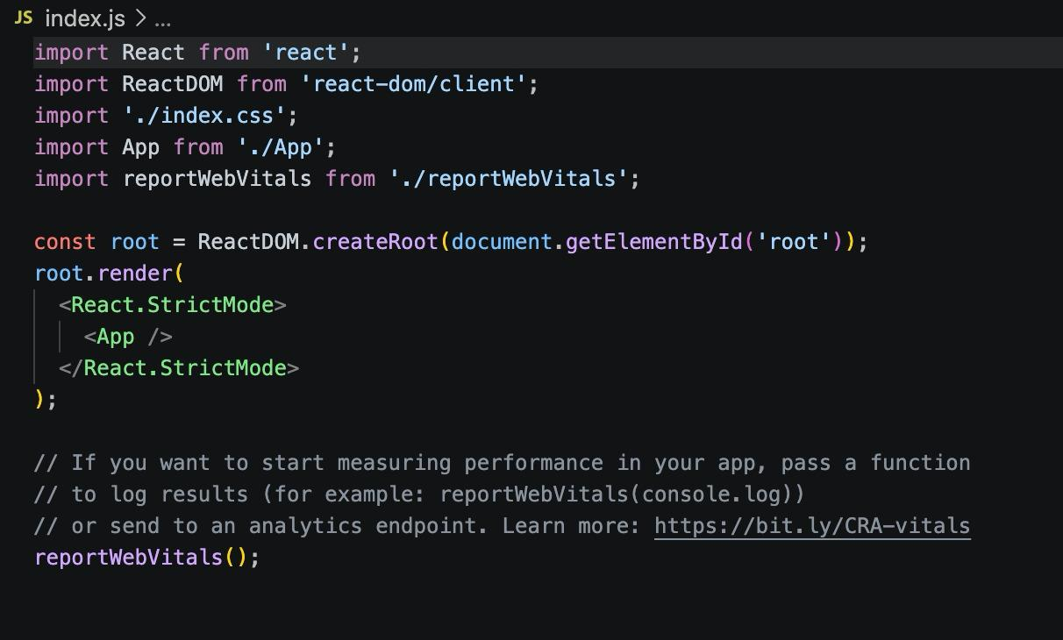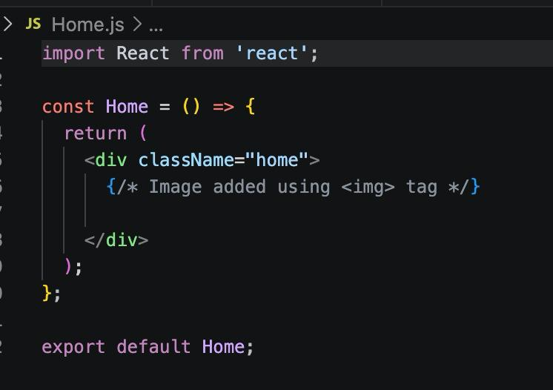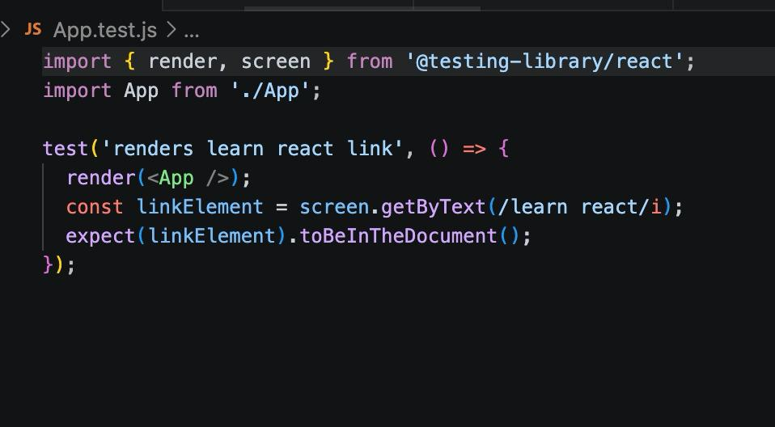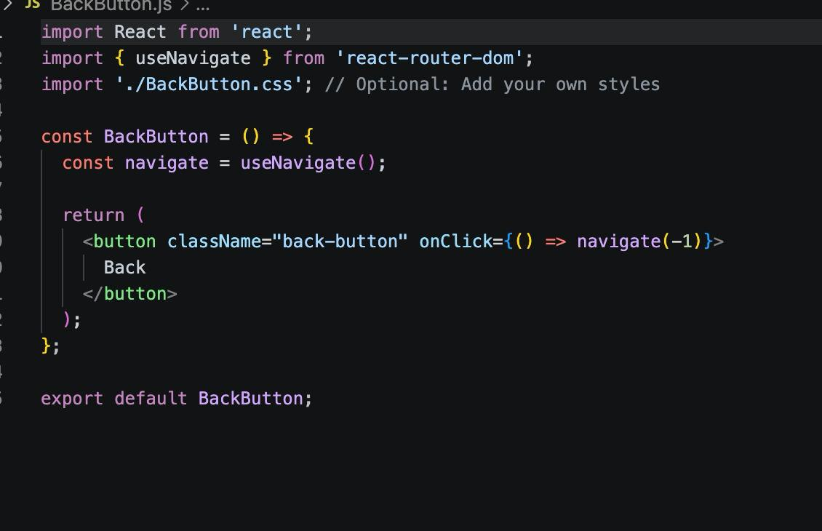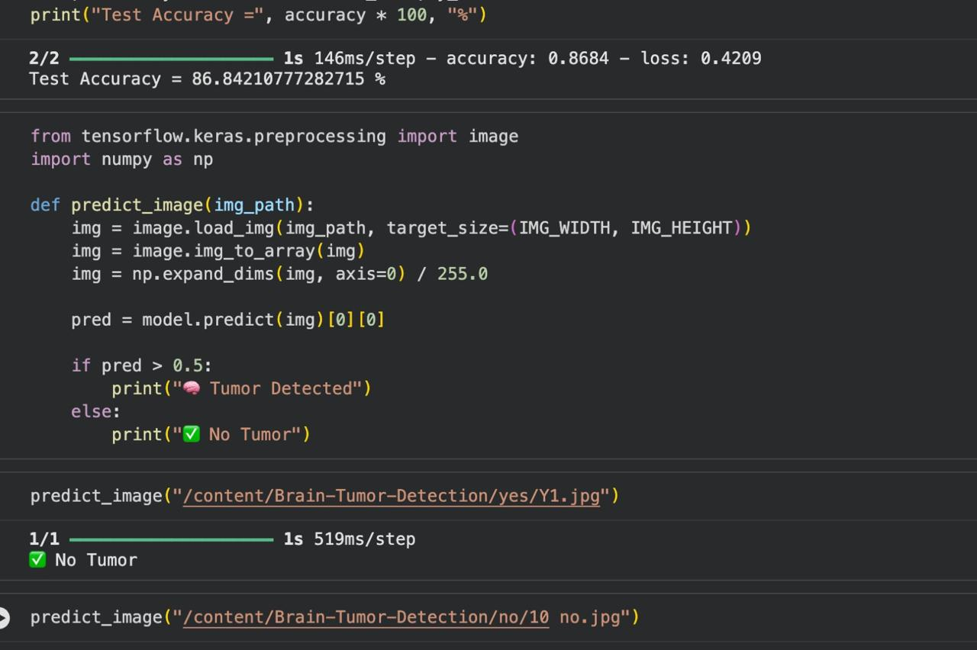
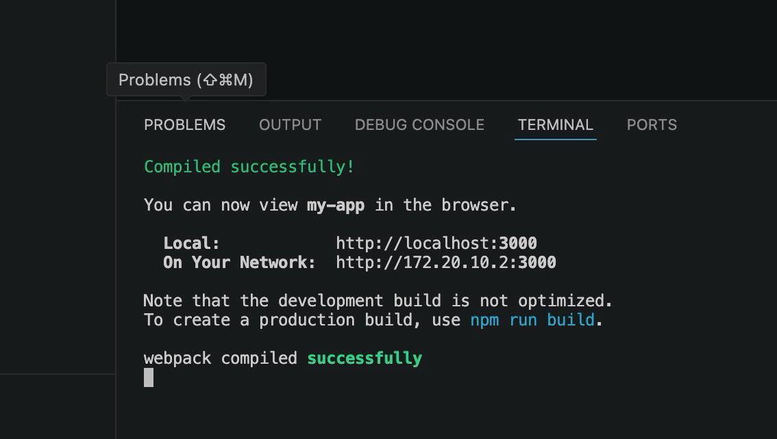

Summary
The Digital Cleanliness Monitoring System is designed to modernize and simplify the process of managing cleanliness-related complaints within educational institutions. The system enables students and staff to register complaints with image uploads, track complaint status, provide feedback, and stay informed about campus events. By integrating MongoDB for data storage and Node.js with Express.js for backend operations, the application ensures efficient handling of data and smooth communication between users and administrators. The platform reduces paperwork, improves transparency, enhances accountability, and ensures timely resolution of issues. Overall, the project contributes to maintaining a cleaner and healthier campus environment through a digital and user-friendly approach.
The project digitalizes cleanliness complaint management within the institution. It reduces manual reporting, improves transparency, and enables administrators to monitor complaint resolution efficiently.

Conclusion
The Digital Cleanliness Monitoring System successfully provides a centralized platform for reporting, monitoring, and resolving cleanliness-related problems. The system strengthens communication between students and administrators and helps in achieving faster complaint resolution and better maintenance of campus facilities. Features such as image uploads, status tracking, event management, and feedback collection enhance the effectiveness and usability of the application. The project demonstrates the practical implementation of modern web technologies and database management concepts. In the future, additional functionalities such as mobile application support, real-time notifications, and AI-based waste detection can further improve the system and contribute to creating smarter and cleaner campuses.

